

OpenL Tablets Demo Package Guide

OpenL Tablets 5.13
OpenL Tablets BRMS

Revised: 09-22-2014

OpenL Tablets Documentation is licensed under a Creative Commons Attribution 3.0 United States License.

Table of Contents
1 Preface 4
1.1 Audience 4
2 OpenL Tablets Demo Package 5
2.1 WebStudio in Demo Package 6
Rules Editor 7
Repository Editor 7
Administration 8
2.2 Web Services in Demo Project 9
2.3 Web Services Demo Client in Demo Package 10
2.4 OpenL Tablets Demo Package as Common Deployment Pattern 11

Preface
This preface is an introduction to the OpenL Tablets Demo Package Guide.
The following topics are included in this preface:
- Audience
- Typographic Conventions

Audience
This guide describes a complete OpenL Tablets Demo package which contains configured and ready to demonstrate infrastructure for the OpenL Tablets product. The Demo enables a user to develop business rules and manage business rule sets in OpenL Tablets WebStudio, and then execute these rules as Web Services ready to be used by solution applications.Typographic Conventions
The following styles and conventions are used in this guide:
Typographic styles and conventions
Convention | Description
Bold | - Represents user interface items such as check boxes, command buttons, dialog boxes, drop-down list values, field names, menu commands, menus, option buttons, perspectives, tabs, tooltip labels, tree elements, views, and windows.  - Represents keys, such as F9 or CTRL+A.  - Represents a term the first time it is defined.
Courier | Represents file and directory names, code, system messages, and command-line commands.
Courier Bold | Represents emphasized text in code.
Select File > Save As | Represents a command to perform, such as opening the File menu and selecting Save As.
Italic | - Represents any information to be entered in a field.  - Represents documentation titles.
< > | Represents placeholder values to be substituted with user specific values.
Hyperlink | Represents a hyperlink. Clicking a hyperlink displays the information topic or external source.
[name of guide] | Reference to another guide that contains additional information on a specific feature.

OpenL Tablets Demo Package
To make work with WebStudio more comfortable and quick to start, several rule projects are already loaded in the user workspace. As a result, the user can work on projects already created from OpenL Tablets Templates or, when necessary, create their own projects via Repository in WebStudio. In addition to demonstrate usage of rules in applications, the user can also invoke rules of the preloaded project via the Web Services Demo Client application deployed in Demo package by default.
Demo package is a ZIP file can be downloaded from http://openl-tablets.sourceforge.net/downloads page, Demo (ZIP) link. After unzipping this file, the Demo package consists of web server Apache Tomcat, version 7.0.40, with four web applications located in the \apache-tomcat-7.0.40\webapps\ folder.
Note! There is no need to set up jdk. Demo Package also works with only jre installed.
These applications are as follows:
- webstudio.war
- webservice.war
- webservice-client.war
- production-repository-server.war
Note: As a production-repository-server, Jackrabbit Web Application version 2.4.4 is used.
For Windows, to start OpenL Tablets Demo Package, locate the <unzipped Demo package folder>\apache-tomcat-7.0.40\bin\startup.bat file and run it by double-clicking or via console window commands.
However, there are some specifics of launching OpenL Tablets Demo Package under Linux. A working directory for OpenL Tablets Demo Package is located <unzipped Demo package folder>\apache-tomcat-7.0.40\bin\openl-demo\. After unzipping the OpenL Tablets Demo Package ZIP file, the user must change access rights to the following folder: sudo chmod 775 -R /<unzipped Demo package folder>.
To get more information, refer to [OpenL Tablets Installation Guide] Deploying OpenL Tablets WebStudio.
After starting Demo, WebStudio installation wizard doesn’t appear. WebStudio is preconfigured in single user mode. The user sees OpenL Tablets Demo welcome page at start.
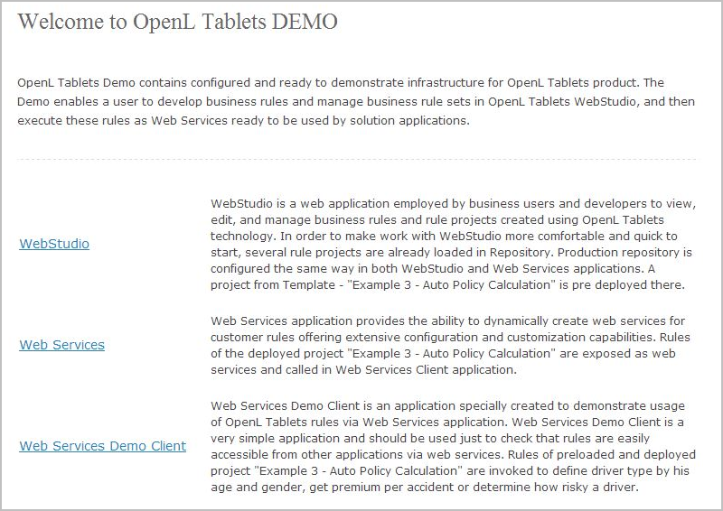
Figure 1: OpenL Tablets Demo welcome page
You can use the following links to the applications from OpenL Tablets Demo welcome page:
Applications and links
Demo application | Url
Webstudio | http://localhost:8080/webstudio
Webservice | http://localhost:8080/webservice
Webservice-client | http://localhost:8080/webservice-client
Note: After starting Demo, WebStudio installation wizard does not appear. WebStudio is preconfigured in a single user mode. The user sees WebStudio welcome start page.
The sections below provide more details on Demo Package work:
- WebStudio in Demo Package
- Web Services in Demo Project
- Web Services Example Client in Demo Package
- OpenL Tablets Demo Package as Common Deployment Pattern

WebStudio in Demo Package
Note: WebStudio is preconfigured in a single user mode. The user is automatically signed in and sees the welcome start page.
The following topics are included:
- Rules Editor
- Repository Editor
- Administration

Rules Editor
Several Examples and Tutorials are already in the Editing status, therefore available in Rules Editor by default. For information how to manage rules in Rules Editor, please refer to [OpenL Tablets WebStudio User Guide], Using Rules Editor.
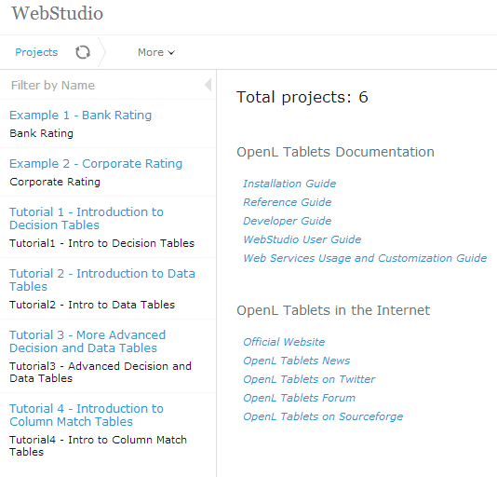
Figure 2: Projects in Rules Editor available for editing

Repository Editor
For information how to manage projects in Repository, see [OpenL Tablets WebStudio User Guide], Using Repository Editor.
Users can work with projects loaded in Repository in Demo package and create their own new projects.
“Example 3 - Auto Policy Calculation” project already deployed using Deploy configuration “Example 3 - Auto Policy Calculation”, can be used via Web Services in Web Services Demo Client.
As WebStudio is preconfigured in a single user mode, all projects in Repository are created and modified by the ”DEFAULT” user.
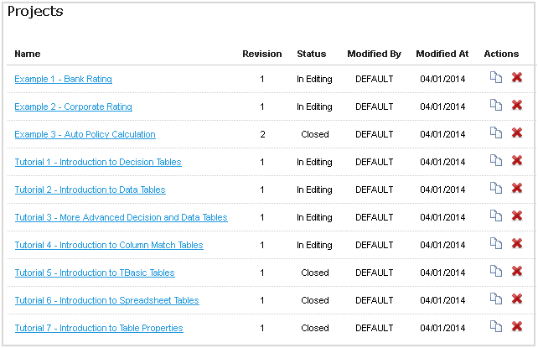
Figure 3: The whole list of rules projects in Repository of Demo Package

Administration
By default, User Workspace, History and Design Repository are configured as local and located in the openl-demo folder of directory <unzipped Demo package folder>\apache-tomcat-7.0.40\bin\. This setting is made to simplify configuration and usage of Demo Package. Note that default directory can be changed to another one. For information how to change a default directory, see [OpenL Tablets WebStudio User Guide], Managing System Settings.
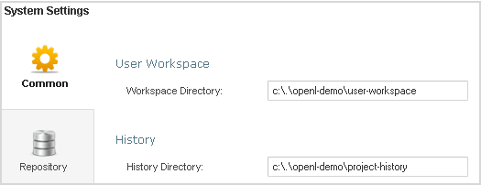
Figure 4: Common system settings in Administration
Production Repository is set to use Remote – RMI connection. An appropriate URL (//localhost:1099/production-repository) is configured by default and defined in WebStudio rules-production.properties file in folder <unzipped Demo package folder>\apache-tomcat-7.0.40\webapps\webstudio\WEB-INF\conf\.
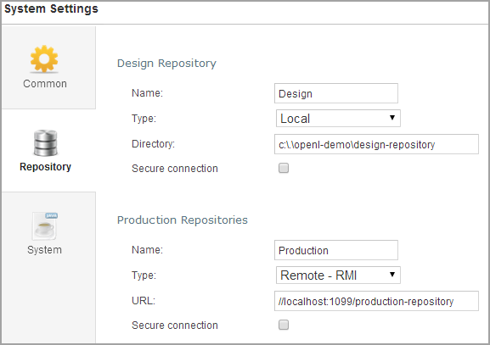
Figure 5: Settings of Design and Production repositories in Administration

Web Services in Demo Project
By default, a project from the “Example 3 – Auto Policy Calculation” template is deployed to Production Repository.
To use this project as an example of project deployments, as described in Web Services Demo Client, several settings are defined in Rules Configuration of the project. It is set up that only *DriverRisk*, *DriverAgeType*, *AccidentPremium*, these are wildcards, rules are included and can be used from the Web Services Demo Client application.
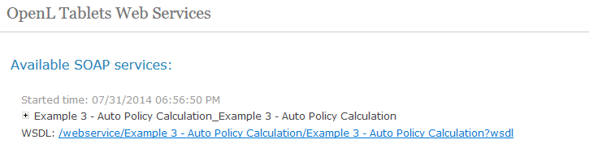
Figure 6: Web Services main page and the project deployed on it
The demo does not restrict any deployments of other projects or has any other limitations so the users can deploy their own projects in Demo setup. If the user deploys anything else, a full list of deployed projects appears on this page including the user’s projects.

Web Services Demo Client in Demo Package
Web Services Example Client application is an application specially created to demonstrate usage of OpenL Tablets rules via Web Services application. Web Services Demo Client is a simple application that must be used to check that rules are easily accessible from other applications via web services.
Note: The Web Services Demo Client invokes only several methods of a particular predeployed “Example 3 – Auto Policy Calculation” project. It means that other projects deployed by the user cannot be used from within the Web Services Demo Client application.
Web Services Demo Client application allows to define a driver type by age and gender, get Premium per accident, or determine how risky a driver is according to Business Rules specified in the “Example 3 - Auto Policy Calculation” project.
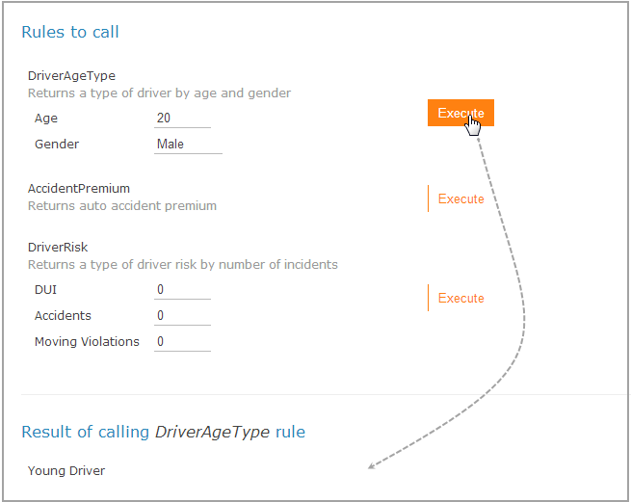
Figure 7: Executing DriverAgeType rule and getting results via Web Services Demo Client
The user can change the values of input parameters in the fields and click the Execute button. The corresponding result displays below the list of rules to call.

OpenL Tablets Demo Package as Common Deployment Pattern
The easiest way to get introduced to using OpenL Tablets rules as Web Services in the application is to explore OpenL Tablets Demo Package. This Demo configuration represents a general usage scenario of the OpenL Tablets product.
Common deployment scenario is as follows:
- Deploy Web Services application, WebStudio application, and Rules Repository application, i.e. jackrabbit JCR into the web server.
- Configure JCR, i.e. jackrabbit settings, repository configurations in WebStudio, and Web Services application. Ensure the ”production” repository is configured the same way in both applications, see configurations in Demo.
- Put preinitialized rules repository on the file system, i.e. jackrabbit repository according to the settings for JCR.
- Run web server. ensure JCR application starts first.
Note: Preinitialized jackrabbit repository is required because jackrabbit cannot initialize repository in the remote mode. As an option, run WebStudio with jackrabbit configured as local and take the fresh repository it creates.

